**ONS Energy client Management Portal Demo- ONSX**

**Page-1**

The picture above shows the login page of the ONS Portal, where the client can log in to their account using the email domain provided by ONS Energy (e.g., clientmanagement@ons.energy) and their password. The page also includes a “Remember Me” option and a “Forgot Password” button.

**Page -2- This page refers to see the site details**

**The image shown above displays tabs that function separately, starting with:**

* **Electricity** – *Total registered MPANs* refers to the total electricity sites. *Upcoming registrations* refers to the sites that are yet to be registered.
* **Gas** – *Total registered MPRNs* refers to the total gas sites. *Upcoming registrations* refers to the sites that are yet to be registered.
* **Water** – *Total registered SPIDs* refers to the total water sites. *Upcoming registrations* refers to the sites that are yet to be registered.

**From a developer’s point of view** – This data will be consolidated by ONS Energy for electricity, gas, and water, and provided in an Excel spreadsheet

Total Registered MPAN’s format:

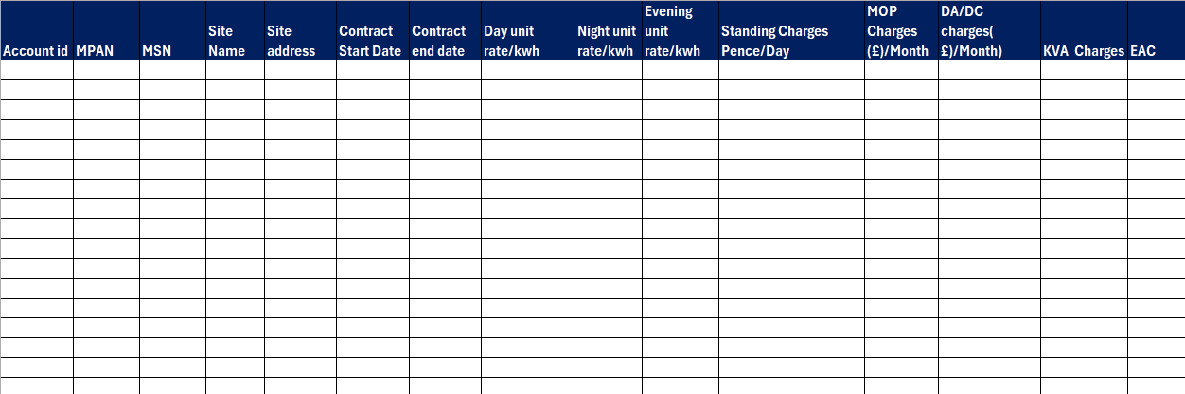

When the client opens and views the **Total Registered Sites** tab, the information shown below will be displayed on that page.

**Data Sources for Developers:**

* **Account ID** – A unique reference number given by the supplier.
* **MPAN** – A unique number used to identify the electricity supply point.
* **Site Name** – The name or reference for the client’s site.
* **Site Address** – The registered address of the site.
* **Contract Start Date** – The date when the new supplier started supplying.
* **Contract End Date** – The date when the contract will expire.
* **Day Unit Rate** – The contracted unit rate in pence/kWh for daytime usage.
* **Night Unit Rate** – The contracted unit rate in pence/kWh for night usage.
* **Evening Unit Rate** – The contracted unit rate in pence/kWh for evening usage.
* **Standing Charges** – The daily meter charges in pence/kWh.
* **MOP Charges** – Meter Operator charges (in £ per month) that some suppliers bill separately.
* **DC/DA Charges** – Data Collector/Data Aggregator charges (in £ per month), billed similarly to MOP charges.

**KVA Charges:**

* The customer is charged a fixed amount per kVA per month (or per day), even if they don’t use the full capacity.

**EAC** – Estimated Annual Consumption of the meter/site.

**Note for Developer:**  
All of the above data will be provided by ONS Energy. After gathering the information, the developer only needs to display this spreadsheet on the portal.

In the above shown image this will be a same format but just account id cell will be missing and Cell

Objections means:

The previous supplier objected the supply and supply hasn’t moved yet and in the same format it will show the objections as shown In previous tabs

Note: The Data will be updated by ONS Energy or Maybe ONS will get the API’s from Supplier to show real time objection, registered and Objections. The cell texts will be in red color

**Accurate Bill Validation.**

In this page the client will be able to see the validated invoice by ONS energy and uploaded by ONS

When the customer will click on this page there will be the invoices uploaded by ONS energy

The tabs will look like

**When the client will click on Total Validated invoices**

|  |  |  |  |  |  |  |  |  |  |  |
| --- | --- | --- | --- | --- | --- | --- | --- | --- | --- | --- |
| MPAN | Generation Date | Bill Ref No. | Type | From Date | To Date | Due Date | Amount(£) | Status | VAT | Download Bill |
| 2.0001E+12 | 02-07-2025 | 2507000836 | Bill | 01-06-2025 | 30-06-2025 | 08-07-2025 | 86.07 | Paid | 5% | Download Button |
| 1.0235E+12 | 21-05-2025 | 2505001074 | Bill | 20-04-2025 | 19-05-2025 | 04-06-2025 | 593.7 | Paid | 20% | Download Button |
| 1.0124E+12 | 02-07-2025 | 2507000279 | Bill | 01-06-2025 | 30-06-2025 | 08-07-2025 | 2,262.83 | Paid | 20% | Download Button |
| 1.0124E+12 | 02-05-2025 | 2505000685 | Bill | 08-04-2025 | 30-04-2025 | 09-05-2025 | 212.56 | Paid | 20% | Download Button |
| 1.0235E+12 | 21-06-2025 | 2506001158 | Bill | 20-05-2025 | 19-06-2025 | 05-07-2025 | 1,239.67 | Unpaid | 20% | Download Button |
| 2.0001E+12 | 02-06-2025 | 2506000834 | Bill | 03-05-2025 | 31-05-2025 | 06-06-2025 | 80.89 | Paid | 20% | Download Button |
| 1.1E+12 | 02-07-2025 | 2507000509 | Bill | 01-06-2025 | 30-06-2025 | 08-07-2025 | 127.08 | Paid | 20% | Download Button |
| 1.0124E+12 | 02-08-2025 | 2508000723 | Bill | 01-07-2025 | 31-07-2025 | 08-08-2025 | 286.49 | Paid | 20% | Download Button |
| 1.0124E+12 | 02-08-2025 | 2508000723CN | Credit Note | 01-07-2025 | 31-07-2025 | 08-08-2025 | 0 | Paid | 20% | Download Button |
| 1.1E+12 | 03-06-2025 | 2506000590 | Bill | 29-04-2025 | 31-05-2025 | 17-06-2025 | 139.66 | Paid | 20% | Download Button |

to select the month January February March so customer can simply review the validated bills for that Particular month only and apply filter to check the total outstanding of electricity invoices validated by ONS energy , this data can be uploaded by ONS energy or can connect API’s directly from supplier

to Download the HH data and Invoice which was validated by ONS energy

And Same goes with incorrect invoices in this format

|  |  |  |  |  |  |  |  |  |  |  |  |
| --- | --- | --- | --- | --- | --- | --- | --- | --- | --- | --- | --- |
| MPAN | Generation Date | Bill Ref No. | Type | From Date | To Date | Due Date | Amount(£) | Status | VAT | Download Bill | Query |
| 2.0001E+12 | 02-07-2025 | 2507000836 | Bill | 01-06-2025 | 30-06-2025 | 08-07-2025 | 86.07 | Unpaid | 5% | Download Button | Incorrect Initial reads |
| 1.0235E+12 | 21-05-2025 | 2505001074 | Bill | 20-04-2025 | 19-05-2025 | 04-06-2025 | 593.7 | Unpaid | 20% | Download Button | Estimated reads |
| 1.0124E+12 | 02-07-2025 | 2507000279 | Bill | 01-06-2025 | 30-06-2025 | 08-07-2025 | 2,262.83 | Unpaid | 20% | Download Button | Faulty meter |
| 1.0124E+12 | 02-05-2025 | 2505000685 | Bill | 08-04-2025 | 30-04-2025 | 09-05-2025 | 212.56 | Unpaid | 20% | Download Button | Incorrect Initial reads |
| 1.0235E+12 | 21-06-2025 | 2506001158 | Bill | 20-05-2025 | 19-06-2025 | 05-07-2025 | 1,239.67 | Unpaid | 20% | Download Button | Estimated reads |
| 2.0001E+12 | 02-06-2025 | 2506000834 | Bill | 03-05-2025 | 31-05-2025 | 06-06-2025 | 80.89 | Unpaid | 20% | Download Button | Faulty meter |
| 1.1E+12 | 02-07-2025 | 2507000509 | Bill | 01-06-2025 | 30-06-2025 | 08-07-2025 | 127.08 | Unpaid | 20% | Download Button | Incorrect Initial reads |
| 1.0124E+12 | 02-08-2025 | 2508000723 | Bill | 01-07-2025 | 31-07-2025 | 08-08-2025 | 286.49 | Unpaid | 20% | Download Button | Estimated reads |
| 1.0124E+12 | 02-08-2025 | 2508000723CN | Credit Note | 01-07-2025 | 31-07-2025 | 08-08-2025 | 0 | Unpaid | 20% | Download Button | Faulty meter |
| 1.1E+12 | 03-06-2025 | 2506000590 | Bill | 29-04-2025 | 31-05-2025 | 17-06-2025 | 139.66 | Unpaid | 20% | Download Button | Incorrect Initial reads |

**The above mentioned formats applies on all tabs Gas electricity and Water.**

**Page -3**

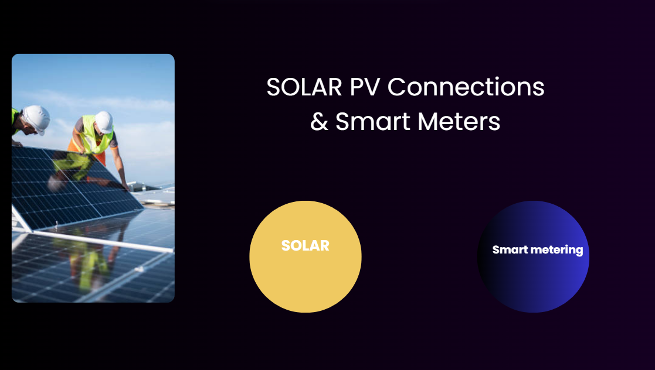

**SOLAR-**

The Above mentioned picture will reflect the status of SOLAR panel installation for the customer sites and Smart meter installation track, this will be the easiest tab where simply we just need to show the information Site address and

|  |  |  |  |
| --- | --- | --- | --- |
| **Site address** | **Installation Date** | **Status** | **upcoming Installation** |
| xyz | 13-09-2025 | Installed | Na |
| xyz | Na | Upcoming | 12-10-2025 |
|  |  |  |  |

**Smart Metering-**

In the Smart metering Tab we will reflect the status of Smart meter installation dates booked and Job status: in below format

|  |  |  |  |  |  |
| --- | --- | --- | --- | --- | --- |
| **MPAN/MPRN** | **Fuel** | **MOP** | **Job id** | **Status** | **Installation Date** |
| 1828323293 | Gas | Imserv | 144483 | Installed | 22-01-2026 |
| 2.33838E+11 | Electricity | SMS | 63374 | Installed | 20-08-2026 |
| 27274743 | Electricity | Imserv | 34412 | Upcoming installation | 20-10-2026 |
| 73848843 | Electricity | Imserv | Na | Not eligible for smart Meter | NA |
| 23321133 | Gas | SMS | 78833 | JOB status failed | NA |

Please note we need to show the dispositions for Status so customer can select the installed, Job status failed etc.

**Page-4 Meter Consolidation**

Meter Consolidation means we will be switching the Meters under one Supplier and now we will need to show the customer the supplier for existing Meters and status of Meter consolidation

|  |  |  |  |  |  |  |  |  |
| --- | --- | --- | --- | --- | --- | --- | --- | --- |
| **Site address** | **Type** | **MPAN/MPRN** | **Supply start date** | **Contract end date** | **Supplier** | **EAC** | **Status** | **Action** |
|  | Gas |  |  |  |  |  |  |  |
|  | Electricity |  |  |  |  |  |  |  |
|  | Water |  |  |  |  |  |  |  |
|  |  |  |  |  |  |  |  |  |
|  |  |  |  |  |  |  |  |  |
|  |  |  |  |  |  |  |  |  |
|  |  |  |  |  |  |  |  |  |
|  |  |  |  |  |  |  |  |  |
|  |  |  |  |  |  |  |  |  |
|  |  |  |  |  |  |  |  |  |

Above format will be used for meter consolidation Page customer can see who is the current supplier

**Page – 5 Storing Document and Carbon Reports**

These tabs will show the important documents of the client such as VAT forms, Complaint procedures, Meter Pictures, site mapping, Where client can apply filter on VAT form and Fill postcode and see the document.

Monthly EDI- Report the client will be able to see the month wise Energy report which will be uploaded by ONS energy

Carbon Reports- Received by consultant and uploaded by ONS energy

**Page- 6 HH DATA & Meter reads**

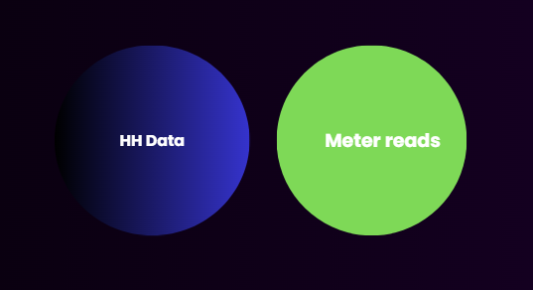

In this Page we will be showing the client the HH data and Meter reads

Where the client can see the List of HH sites in HH Data,

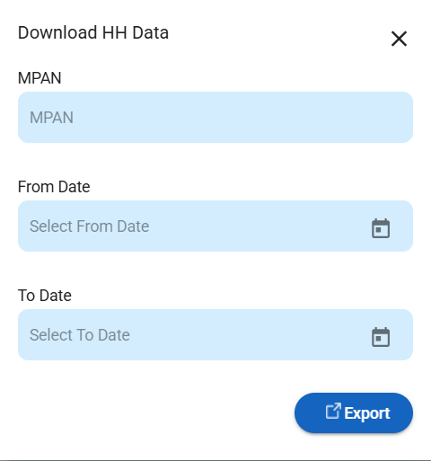

In above format they fill MPAN and select date and export the API’s can be connected with supplier Portal

And In the meter reads Section can see the meter reads submitted for this tab as well API’s can be connected with supplier Portal

**Page-6**



The above tab will reflect the Monthly final report submitted by ONS energy for client review that will be the final report to pay the amount